83-87/180

{MiM-Blue}

Porter Lakes Elementary

This Week

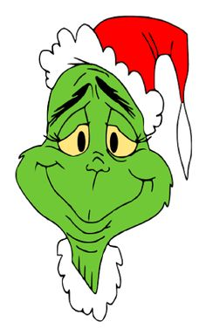December 14 – 18, 2020

*Vah who door-aze*

*Vah who door-aze*

 *Welcome Christmas,*

*Bring your cheer*

*Cheers to all Whos far and near*

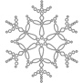*Christmas day is in our grasp*

*So long as we have hands to clasp*

*Christmas day will always be*

*Just as long as we have we*

*Welcome Christmas while we stand*

*Heart to heart and hand in hand*

The Grinch

Dr. Seuss, 1966



Monday, December 14th

Tuesday, December 15th

9:30-2:00 Angel Tree Pick-Up Office

Wednesday, December 16th

9:30-2:00 Angel Tree Pick-Up Office

Thursday, December 17th

Friday, December 18th **End 2nd Nine Weeks**

CAR RIDER / WALKERS / BUS

|  |  |  |  |  |  |
| --- | --- | --- | --- | --- | --- |
|  | **Car Riders** | | | **Bus** | **Walkers** |
| *12/14* | Birky | Psimos | Heckler | Calipari | Kas/Smitty |

LET’S ALL JUST STAY CALM

Hey – there will be a lot of excitement this week. Unfocused, and off task behaviors will be rampant. Perhaps negative behaviors and acting out… …and then think about the kids…

CONSIDER, RESPOND, AND PONDER

🡿

[In book inscription] “Remember, George: no man is a failure who has friends.”

~ *Clarence – It’s a Wonderful Life*

END SECOND NINE WEEKS

We’ll send / email report cards on Wednesday 1/6/21. I’d like to see them before they go home. – thanks.

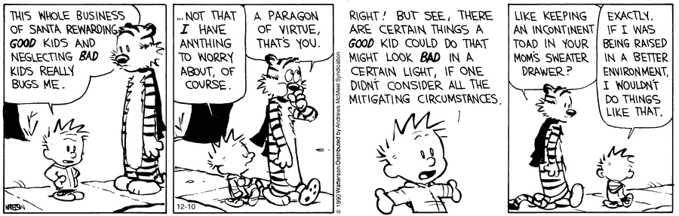

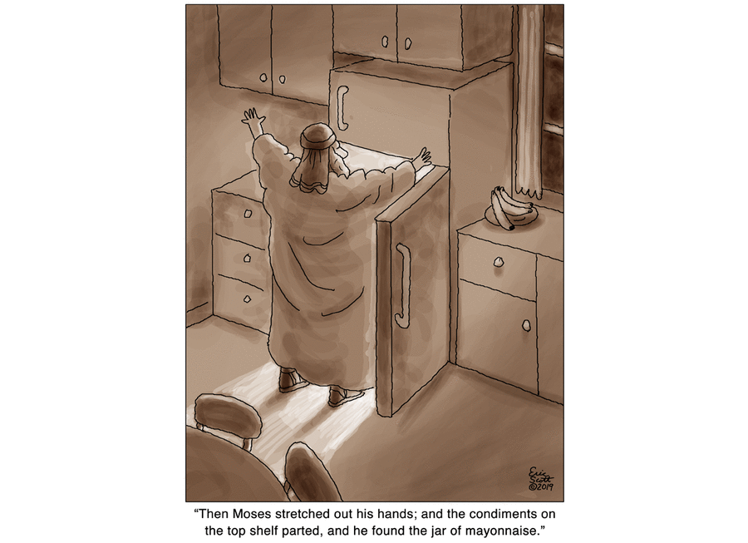

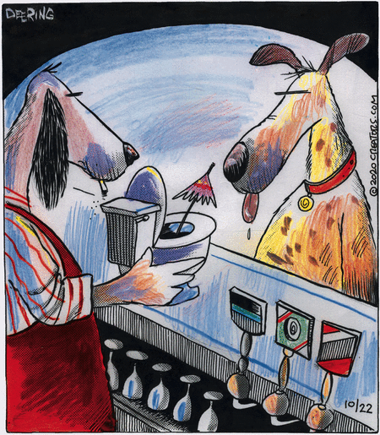

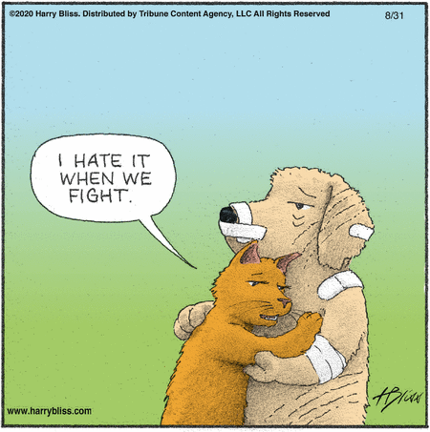

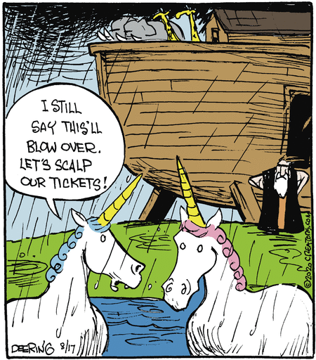

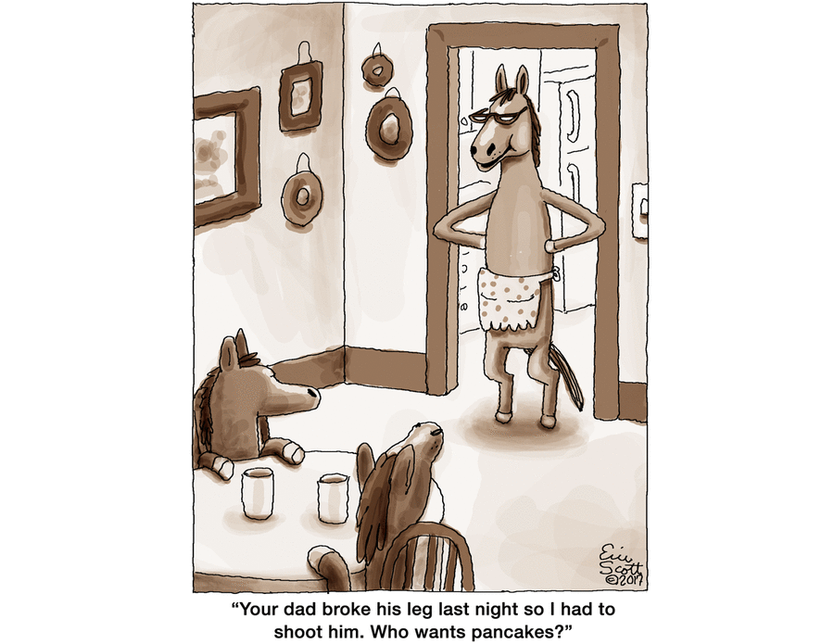

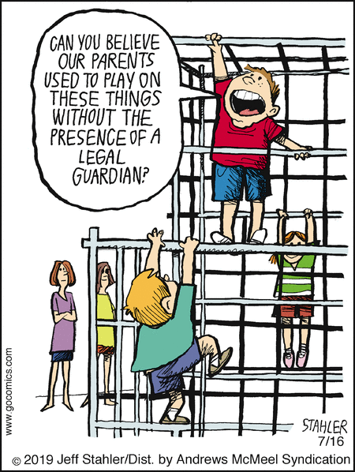

“Did you ever fly a kite in bed? Did you walk with ten cats on our head? Did you ever milk this kind of cow? Well you can do it. We know how. If you never did you should. These things are fun and fun is good” ~ Dr. Seuss

