38-42180
Porter Lakes Elementary
This Week
October 10 – 14, 2022

Book Fair!

Monday, October 10th
{Wear Travel Clothes}

Tuesday, October 11th
{Wear Camping Gear}

Wednesday, October 12th
{Dress Like Your Fav Book Character}

8:55 Late Start* All School
9:15 Fire Prevention {PS/K/1st} Gym
9:50 “ “ {2nd/3rd} “

Thursday, October 13th
{Dress in Past / Future Clothes}

7:45 CTE Field Trip Here & There
8:00 Student of the Month Breakfast Cafeteria
2;45 Early Dismissal All School
3-7:00 P/T Conf Classrooms
5-7:00 Book Fair Parent Night Music Rm.
6:30 School Board Meeting Central Office

Friday, October 14th
{Wear Pajamas}

CAR RIDER / WALKERS / BUS
 | Car Riders |  |  | Bus | Walkers | PS Arrival/Dismissal
10/10 | Johnston | Rhoades | Finley | Corman | Kas/Smitty | Mucha/Bontrager
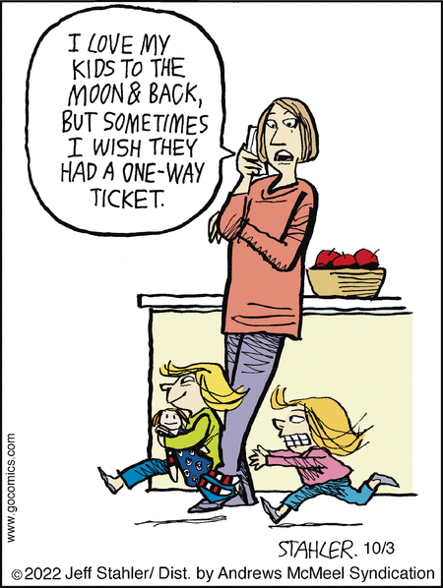
*LATE START
*Conference Prep

REPORT CARDS
*Please be sure you get me your report cards before you hand them out.
*You can send report cards home before conferences or you can hand them out at conferences – which ever you prefer.

PONDER
“I would rather sit on a pumpkin, and have it all to myself, than be crowded on a velvet cushion.”
― Henry David Thoreau

